Adriana Pena

Lab Report 1

Description

The point of this lab was to construct shapes and make methods so that when we are making them we would have to use recursion in them so that they would have multiple shapes inside the shapes that are already done.

Proposed Solution Design and Implementation

For the first shape which was the circles what I did was make the method that would have all the measurements or equations that I would need in order to build the circle. Then the next method I did was to actually draw the circles and that’s where I did the recursion call where the plot would be in the middle referring to the x and y index and subtracting 10 and multiplying it by n times. My next method would be the square this is where the I sort of got lost because when making it what I did was build the sides which where my y and x points then I started at the center point plotting them at the starting to do the recursive method which would decrease the size of the square. The trees method would probably be one of the hardest because I as I got the x and y plotting points I also had to put some points that would probably be the current values so that when I device each branch it would be divided by two and that would create the recursive methods on each side. The first triangle would be the method called triangle where the has to be a triangle for example the one from the squares. I used the variable q in the method so that it would be able make the inside triangle. Then plotting the points and calling the recursive method so that it is able to subtract by 1. In the second triangle I did the same concept drawing the big one on the outside but them making more triangle so in the recursive call what I did was dividing q by 2 so it would divide that distance already set by 2.

Experimental Results

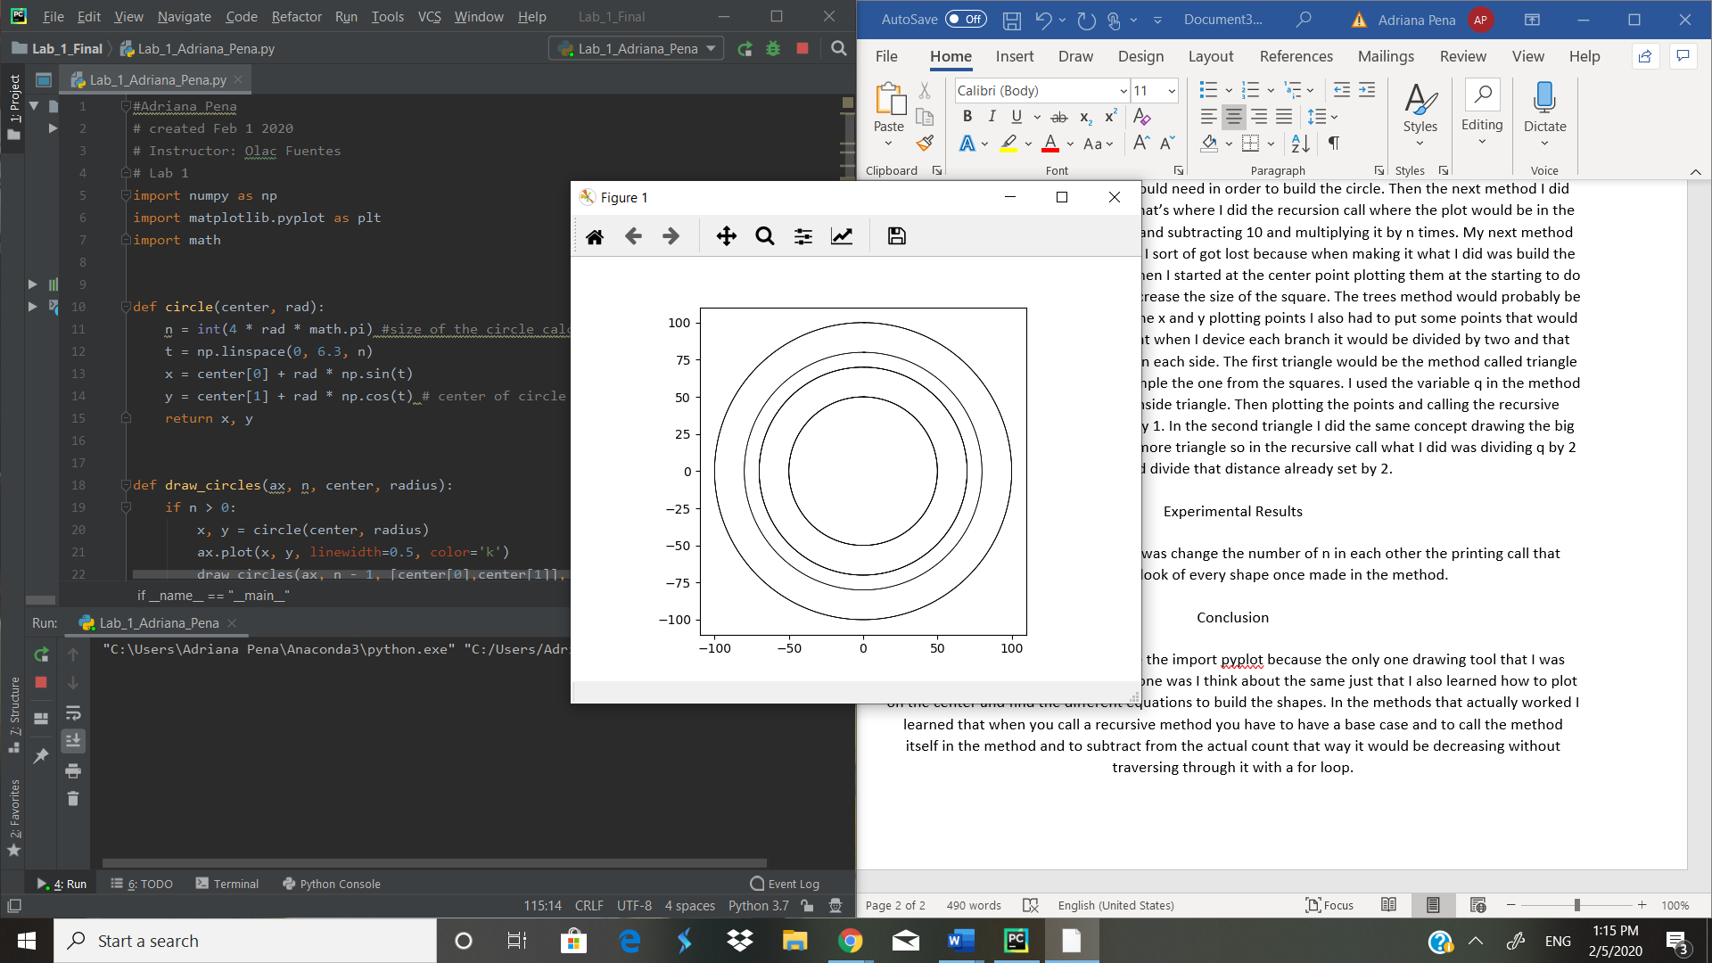For experimental results what I did was change the number of n in each other the printing call that would change the look of every shape once made in the method.

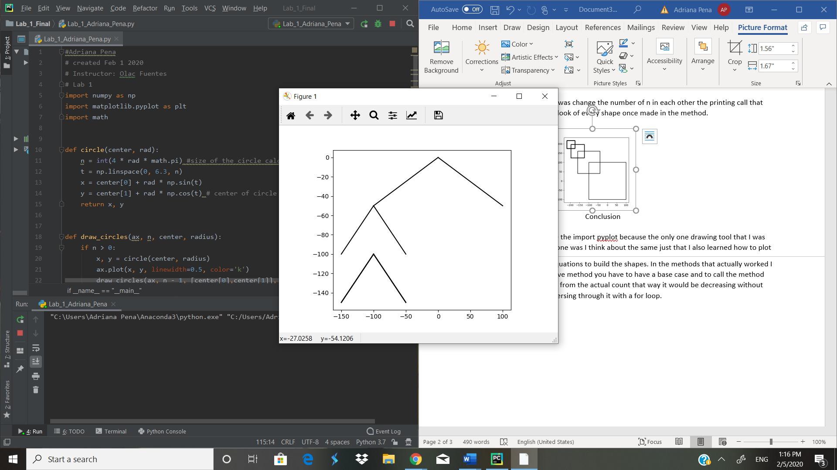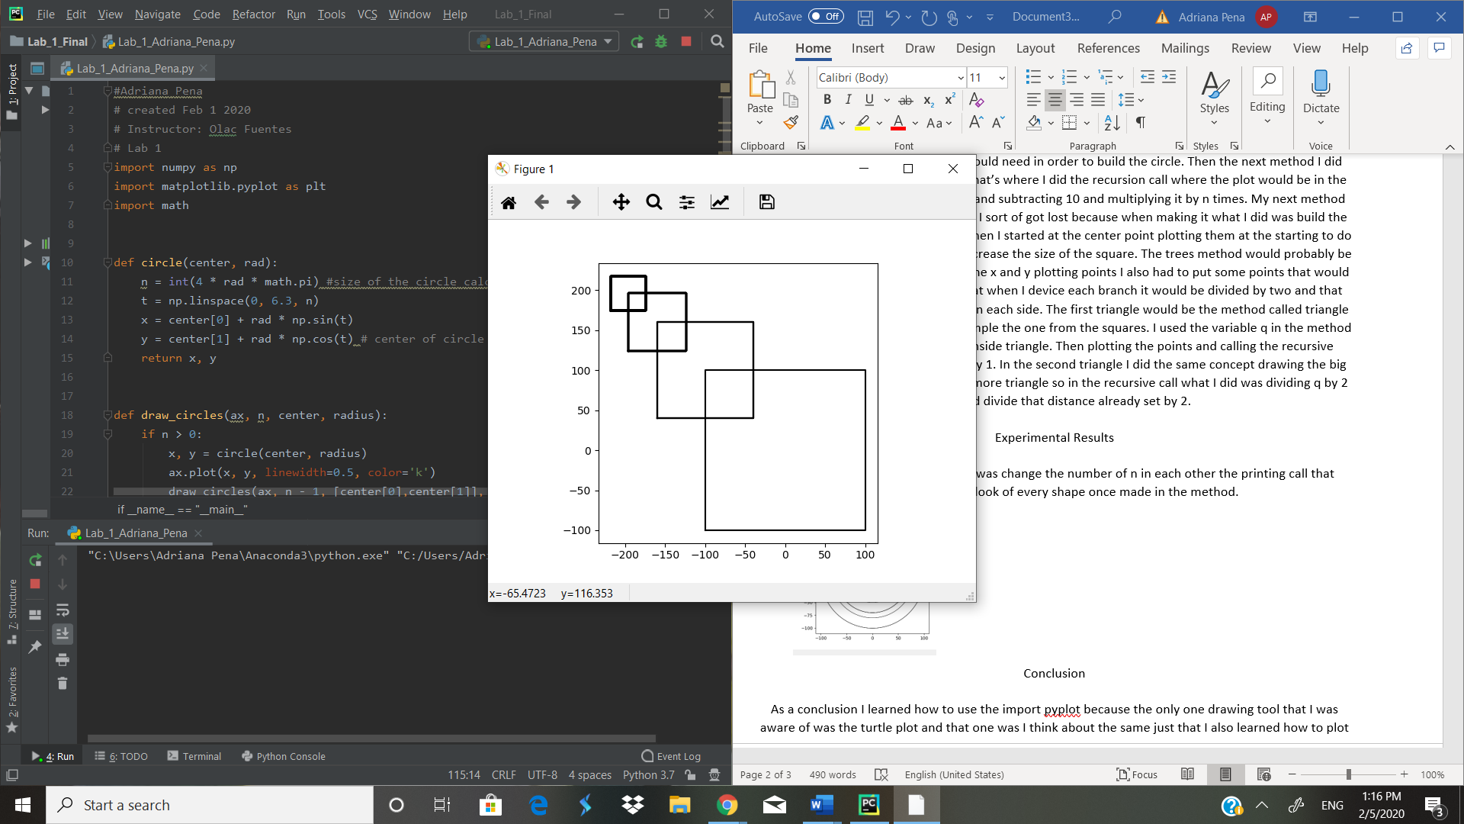

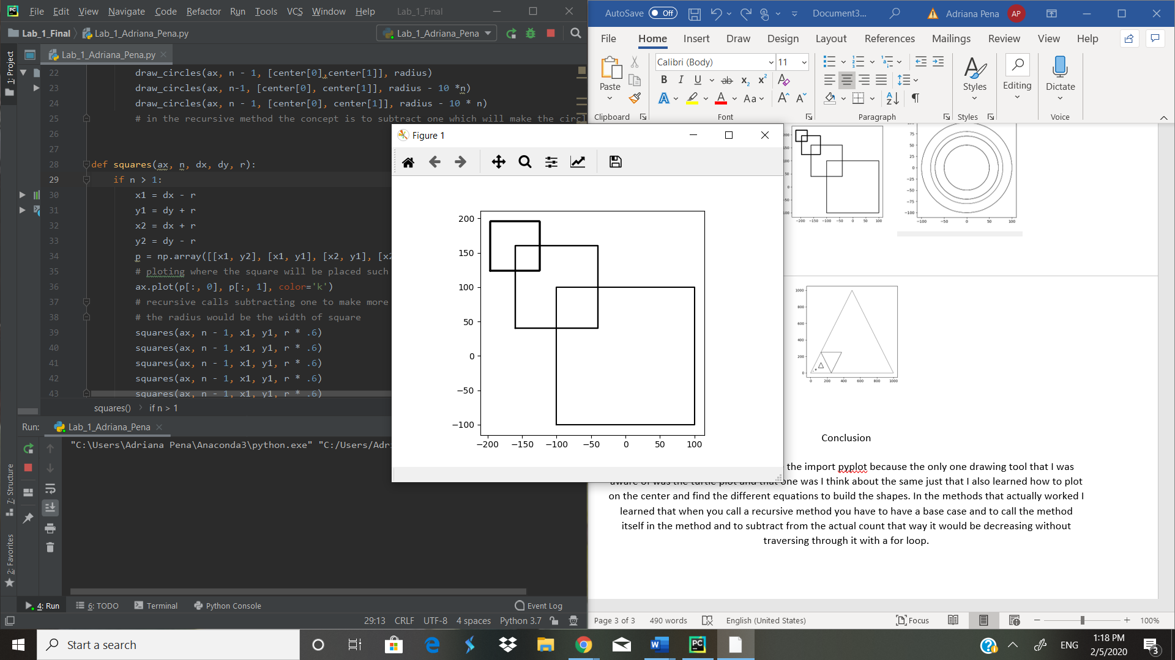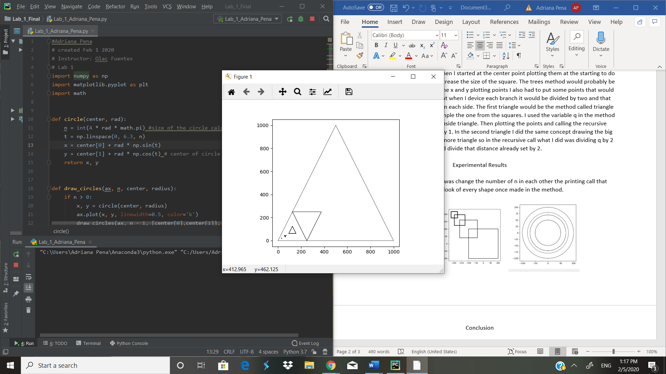

Conclusion

As a conclusion I learned how to use the import pyplot because the only one drawing tool that I was aware of was the turtle plot and that one was I think about the same just that I also learned how to plot on the center and find the different equations to build the shapes. In the methods that actually worked I learned that when you call a recursive method you have to have a base case and to call the method itself in the method and to subtract from the actual count that way it would be decreasing without traversing through it with a for loop.

Appendix

<https://github.com/abpena/abpena>